D8.4 Report on Use Cases, Requirements, Metadata and Interoperability of WP 8

Document information Summary

Date | March 27, 2018
Document title: | Report on Use Cases, Requirements, Metadata Catalogue Templates of WP8
Leader Partner | INGV
Main Author(s): | Alberto Michelini
Contributing author(s): | WP8 TCS-ICS liaisons
Reviewer(s): | Luca Trani
Approved by:
Target audiences: | WP6 and WP7
Keywords: | Data, web services, use cases
Deliverable nature: | Report
Dissemination level: | public
Delivery date: | April 12, 2018
Version: | v. 3

Table of Contents

Table of Contents 2
SUMMARY 3
1. Introduction 4
2. Status of the services 4
Existing prioritized services 5
Services that are ready but not prioritized 6
c) services under implementation 9
Computational seismology 11
3. Contribution of the TCS to the DCAT-AP 11
4. AAAI possible or tested solutions 13
6. CONCLUSION 14

SUMMARY
This deliverable reports the status of the TCS-ICS integration of WP8 at M30. For this TCS, 6 basic services have been prioritized successfully and several others are basically ready and just missing the implementation of the metadata through the “editor” that will be provided by the ICS. Finally, 6 are either under advanced development or under development.
The metadata implementation according to the new EPOS-DCAT-AP RDF model is under way.
The EIDA services have successfully tested the AAAI authentication/authorization scheme through the implementation of the B2ACCESS service provided by EUDAT and the use of a “token” for service authorization. Other solutions based on EGI Checkin and NGINX proxy configurations which work with the existing web-services were shown as potential candidates to address the AAAI and will be investigated further.

1. INTRODUCTION

This deliverable describes the state of the art of the services developed within the TCS Seismology. The report is subdivided into three parts - Status of the of the services, contribution of the TCS to the EPOS-DCAT-AP and AAAI possible or tested solutions.

2. STATUS OF THE SERVICES
This section describes the state of the art of the services. Table 1 provides the list of the web-services that were prioritized, Table 2 presents those services that are ready for the mapping to EPOS-DCAT-AP RDF metadata model and Table 3 presents those services that are still under development.

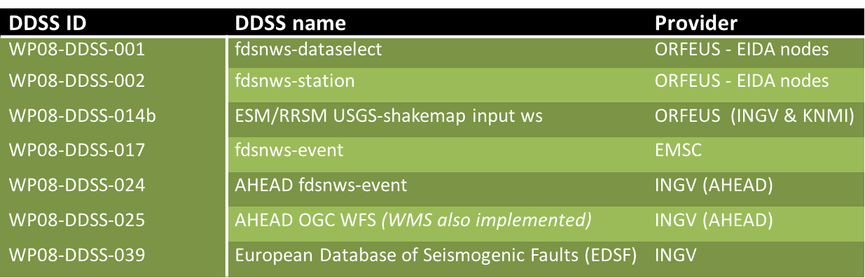
Table 1. List of the web services that have been prioritized.

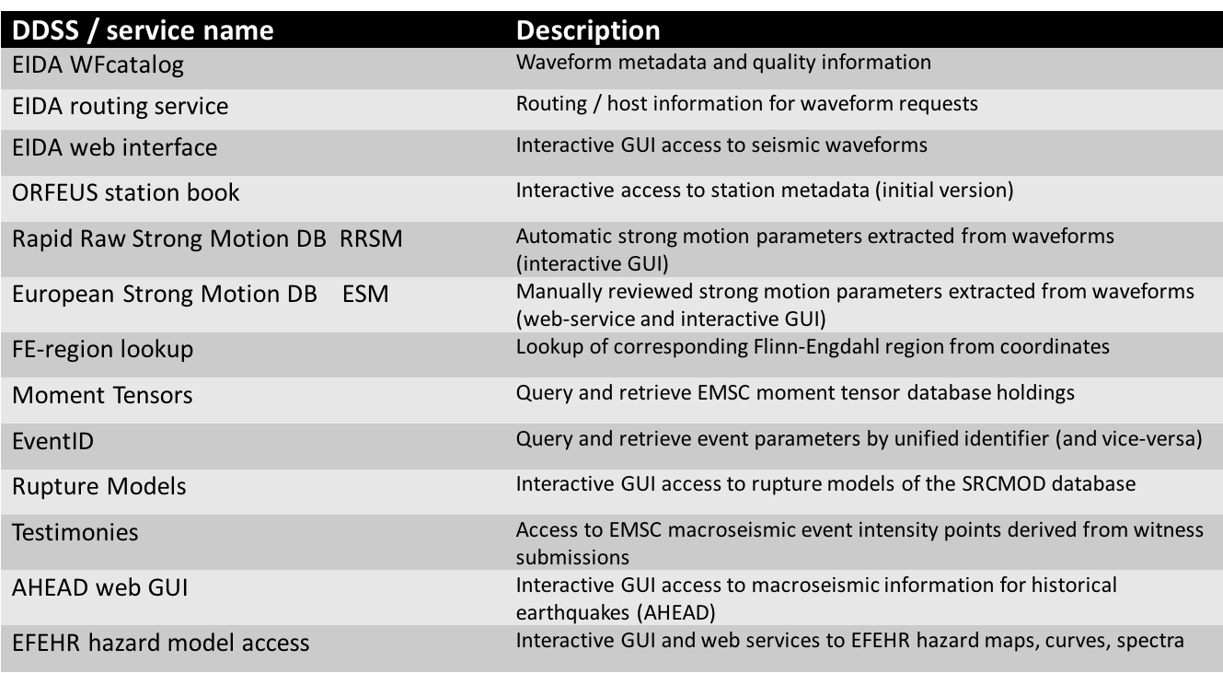
Table 2. List of the web services that are ready for metadata mapping.

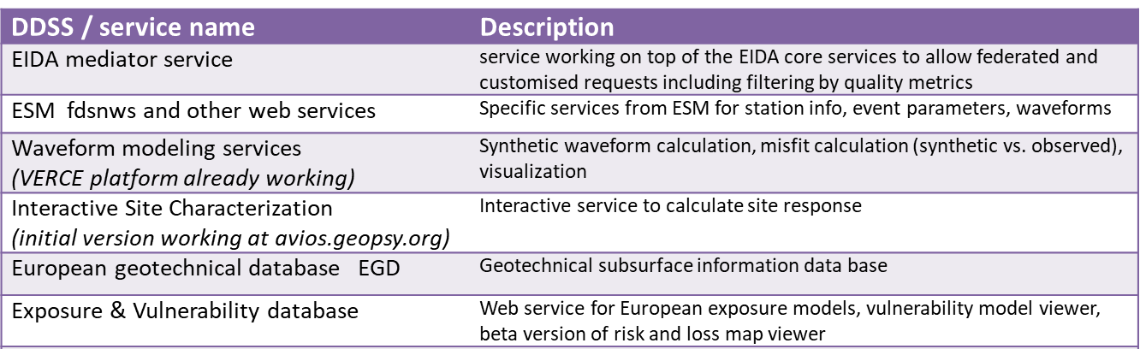
Table 3. List of the (web) services that are still under development and / or cannot be properly described with the current EPOS-DCAT-AP metadata.

Existing prioritized services
  - FDSN
    - Dataselect-WS - the service is used at all the EIDA nodes to expose waveform data in MSEED format that is also the standard format for seismic waveform data within ORFEUS and thus EPOS. AAI support has been added and tested at two selected nodes. Specifications available here: http://www.fdsn.org/webservices/FDSN-WS-Specifications-1.1.pdf
Documentation @ORFEUS: http://www.orfeus-eu.org/data/eida/webservices/dataselect/
    - Station-WS - the service is used at all the EIDA nodes to expose station’s metadata in xml and text as standard output formats. Specifications available here: http://www.fdsn.org/webservices/FDSN-WS-Specifications-1.1.pdf
Documentation @ORFEUS: http://www.orfeus-eu.org/data/eida/webservices/station/
  - ESM Shakemap Web-Service (http://esm.mi.ingv.it/esmws/shakemap/1/) - The ESM Shakemap Web-Service provides machine-readable access to ShakeMap input-files derived from data and metadata included in the ESM Database.
  - FDSN WS-event - Description: Web service dedicated to the exchange of all EMSC event data and parameters (origins and arrivals) and their interoperability within the context of the International Federation of Digital Seismograph Networks (FDSN). [Service URL: http://www.seismicportal.eu/fdsn-wsevent.html; Specs: http://www.fdsn.org/webservices/FDSN-WS-Specifications-1.1.pdf]
  - AHEAD
    - fdsn-event (WP08-DDSS-024). FDSN-event providing preferred and alternative event parameters for historical earthquakes (1000-1899) from AHEAD, the European Archive of Historical Earthquake Data [Service URL: https://www.emidius.eu/fdsnws/event/1/query?; Docs: https://www.emidius.eu/AHEAD/services/events.php]
    - OGC WFS (WP08-DDSS-025) - OGC WFS providing a point layer with epicentres of historical earthquakes (1000-1899) from SHEEC, the SHARE European Earthquake Catalogue that was compiled using AHEAD, the European Archive of Historical Earthquake Data [Service URL: https://www.emidius.eu/services/europe/wfs/?service=WFS&request=getCapabilities; Docs: https://www.emidius.eu/AHEAD/services/events_ogc.php]
  - EDSF – European Database of Seismogenic Faults version 2013 (WP08-DDSS-038) accessible through the web portal http://www.seismofaults.eu. The webservices are distributed through
    - OGC WMS providing access to seven maps obtained by combining data and features belonging to two categories of faults: 1) crustal faults; 2) subduction zones (http://www.seismofaults.eu/index.php/services/edsf13-services).
    - OGC WFS providing access to four layers representing data and features belonging to two categories of faults: 1) crustal faults; 2) subduction zones (http://www.seismofaults.eu/index.php/services/edsf13-services).
    - OGC CSW providing access to the catalogue of metadata related to 1) the dataset, and 2) the services (http://www.seismofaults.eu/index.php/metadata-catalogue).

Services that are ready but not prioritized

  - EIDA
    - WFCatalog - The WFCatalog web service provides detailed information on the contents of waveform data including quality control parameters. Information can be included on sample metrics, record header flags, and timing quality. The service is in production at all nodes at some nodes still in alpha version.
Specifications available here: http://www.orfeus-eu.org/data/eida/webservices/wfcatalog/
Documentation @ORFEUS: http://www.orfeus-eu.org/data/eida/webservices/wfcatalog/
    - Routing Service - the service provides routes to different type of EIDA data as well as used to synchronize routes within the federation.
Documentation @ORFEUS: http://www.orfeus-eu.org/data/eida/webservices/routing/
    - EIDA Web Interface - is the interactive GUI to search for and collect waveform data and corresponding metadata from EIDA, based on a suite of different earthquake catalogues or based on user supplied time windows (reengineered to use the standard web services alongside with the old protocol and the new AAI schema) Arclink. Service running here (as well as at several other nodes): http://www.orfeus-eu.org/webdc3/ Software package available here: http://geofon.gfz-potsdam.de/software/webdc3/
    - ORFEUS Station Book The Station Book website provides extensive information of all stations that are part of the European Integrated Data Archive (EIDA). Service running here: http://orfeus-eu.org/stationbook/

  - ESM
    - Parameters Web-Service (http://esm.mi.ingv.it/esmws/parameters/1/) - The ESM Parameters Web-Service provides machine-readable access to metadata related to waveforms and response spectra included in the ESM Database.
    - Event-Data Web-Service (ESM Event-Data Web-Service) - The ESM Event-Data Web-Service provides machine-readable access to event-based waveforms and response spectra included in the ESM Database.
    - FDSNWS Station Web-Service (http://esm.mi.ingv.it/fdsnws/station/1/) - The ESM FDSNWS Station Web-Service provides machine-readable access station-related metadata included in the ESM Database.
    - FDSNWS Event Web-Service (http://esm.mi.ingv.it/fdsnws/event/1/) - The ESM FDSNWS Event Web-Service provides machine- readable access event-related metadata included in the ESM Database.
    - REXEL-target-spectrum Web-Service (http://esm.mi.ingv.it/esmws/rexel-target-spectrum/1/) - The ESM REXEL-target-spectrum web-service provides access to design acceleration 5%-damping elastic spectra according to Eurocode 8 (EC8) (CEN 2003) or to Italian seismic code (NTC08) (CS.LL.PP. 2008).
    - REXEL-spectra-selection Web-Service (http://esm.mi.ingv.it/esmws/rexel-spectra-selection/1/) - The ESM REXEL-spectra-selection web-service returns the response spectra within the ESM Database sorted by their distance from a target spectrum.
    - REXEL-run-matching Web-Service (http://esm.mi.ingv.it/esmws/rexel-run-matching/1/) - The ESM REXEL-run-matching web-service returns sets of waveforms, whose spectra, on average, match a target spectrum within a specified tolerance

  - EMSC
    - FE-region lookup - Description: The service identifies the Flinn-Engdahl region from a geo-localisation entry point. [Service URL: http://www.seismicportal.eu/feregions.html]
    - Moment Tensors - Description: Web service that allows querying and retrieving all EMSC moment tensors available. [Service URL: http://www.seismicportal.eu/mtws/ Specs:https://www.emsc-csem.org/Files/epos/specifications/Specs_MT-WS.pdf]
    - Event ID - Description: The service allows to retrieve origin parameters of the EMSC catalogue from a unified identifier and to map it to the identifier from other seismological institutions in order to query of distant seismic catalogues. The reverse process if it exists is also allowed. [ Service URL: http://www.seismicportal.eu/eventid/; Specs: https://www.emsc-csem.org/Files/epos/specifications/Specs_EventID-WS.pdf]
    - Rupture Models - Description: The web service allows to recover all rupture models from the SRCMOD database of M. Mai (which is the database of finite-fault rupture models of past earthquakes). These earthquake source models are obtained from inversion or modeling of seismic, geodetic and other geophysical data, and characterize the space-time distribution of kinematic rupture parameters. [Service URL: http://www.seismicportal.eu/srcmodws/; Specs: https://www.emsc-csem.org/Files/epos/specifications/Specs_SRCMOD-WS.pdf]
    - Testimonies - Description: This service allows downloading all the testimonies collected from eyewitness during earthquakes. Felt reports are collected through EMSC websites and Lastquake mobile application. [Service URL: http://www.seismicportal.eu/testimonies-ws/; Specs: https://www.emsc-csem.org/Files/epos/specifications/Specs_Testimony-WS.pdf]
    - Test Platform - Description: The test platform is part of the perspective of testing new seismological products within the framework of EPOS-Seismology and allows to increase knowledge sharing and to animate the scientific community around collaborative means. [Service URL: http://cerf.emsc-csem.org:8080/]

  - AHEAD
    - Bibliography (WP08-DDSS-026) - Bibliography web service providing bibliographical metadata of data sources archived in AHEAD, the European Archive of Historical Earthquake Data [Service URL: https://www.emidius.eu/services/bibliography/query?; Docs: https://www.emidius.eu/AHEAD/services/bibliography.php]
    - OGC WMS (WP08-DDSS-050) - OGC WMS providing a raster layer with epicentres of historical earthquakes (1000-1899) from SHEEC, the SHARE European Earthquake Catalogue that was compiled using AHEAD, the European Archive of Historical Earthquake Data [Service URL: https://www.emidius.eu/services/europe/wms/?service=WMS&request=getCapabilities; Docs: https://www.emidius.eu/AHEAD/services/events_ogc.php]
    - Macroseismic (WP08-DDSS-051) - Macroseismic Data web service providing intensity data for historical earthquakes (1000-1899) from AHEAD, the European Archive of Historical Earthquake Data. The service is functionality ready, but some data are still missing due to legal issues. It will be finalized by October 2018 [Service URL: https://www.emidius.eu/services/macroseismic/query?; Docs: https://www.emidius.eu/AHEAD/services/macroseismic.php]

  - EFEHR
    - Hazard maps Web-services: http://appsrvr.share-eu.org:8080/share/curve?lat=47.5&lon=7.6 [Documentation: http://www.efehr.org/en/Documentation/web-services/hazard-map-data/; Description: provide access to seismic hazard maps of various seismic hazard models (the 2013 European Seismic Hazard Model, the 2014 Earthquake Hazard Model of the Middle East, GSHAP). Selection by point of interest or region of interest (user defined polygon)]
    - Hazard curves Web-services: Documentation: http://www.efehr.org/en/Documentation/web-services/hazard-curve-data/; Description: provide access to seismic hazard curves of various seismic hazard models (the 2013 European Seismic Hazard Model, the 2014 Earthquake Hazard Model of the Middle East). Selection by point of interest (user defined)]
    - Hazard spectra Web-services: http://appsrvr.share-eu.org:8080/share/spectra?lon=7.6&lat=42.5; Documentation: http://www.efehr.org/en/Documentation/web-services/uniform-hazard-spectra/; Description: Provide access to uniform hazard spectra of various hazard models (the 2013 European Seismic Hazard Model, the 2014 Earthquake Hazard Model of the Middle East, GSHAP) for a given location, for various probabilities of exceedance (or mean return periods)]
    - EC8 Elastic Design Spectra: Web-services: http://appsrvr.share-eu.org:8080/share/design-spectra/design_spectra_elastic_ec?lon=7.6&lat=42.5&spectratype=bigmag&imt=SV&design-acceleration=0.02; Documentation: http://www.efehr.org/en/Documentation/web-services/ec8-elastic-design-spectra/. Description: it allows comparisons of the hazard spectrum (in acceleration or velocity) predicted by a hazard model to the Eurocode 8 design spectra, we provide a service to retrieve the design spectra (spectral acceleration or spectral velocity) for a given peak ground acceleration.]

c) Services under implementation

  - Mediator: WS allowing to search different types of data applying filters based on the output from other services. For instance, get waveforms (Dataselect) with a minimum quality (WFCatalog), from stations at a distance to a location (Station-WS) within a certain range. Release date is still not defined.
  - AVIOS site characterisation tool: Current developments in AVIOS are mainly focused on high resolution three-component processing. New theoretical questions are addressed and discussed in a paper to be submitted in a week or so. The new method will be integrated into the web engine during the next weeks (April / May 2018) [Service URL: https://avios.geopsy.org]
  - EFEHR
    - risk maps [Web-services: under development. Description: provide access to seismic risk maps from the European Seismic Risk Model (ESRM2020). Selection by point of interest or region of interest (user defined polygon) Estimated first version: early 2019]
    - risk curves [Web-services: under development. Description: provide access to seismic risk curves from the European Seismic Risk Model (ESRM2020). Selection by point of interest (user defined). Estimated first version: early 2019]
    - vulnerability models [Web-services: under development. Description: provide access to fragility/vulnerability models from a European database of fragility/vulnerability models. Estimated first version: October 2018]
    - exposure models [Web-services: under development. Description: Provide access to exposure data from the exposure model of the ESRM2020. Selection by point of interest or region of interest (user defined polygon). Estimated first version: Early 2019]
  - eGSIM European Ground Shaking Intensity Model [Interaction: through GUI; web-services: not discussed yet. Actions: selection of GMPEs from a library; user-defined rupture scenario; comparison of the selected models in terms of Trellis plot; residual analysis using databases created from published flat files; ranking of the selected models; dissemination of event- and station-residuals. Estimated beta-version: end 2018]
  - European Geotechnical Database (EGD): EGD aims to gather and disseminate, in a homogenized way at European level, existing information useful for site characterization at the sites of permanent station installations or non-instrumented sites. Information is organized in two levels; the first level includes basic parameters such as shear wave velocity values over the top 30 meters of the soil column, resonant frequency and EC8 class, while the second level, more research-oriented, includes extended geophysical and geotechnical profiles. Information will be extractable through the EGD web portal, hosted by AUTH, which is now under active development (egd-epos.civil.auth.gr/). EGD service is expected to be implemented within 2018 and to be integrated within EFEHR.
  - The VERCE platform is an eScience scientific gateway that allows both expert and non-expert users to simulate 3D seismic wavefields generate by earthquakes in a given region and to compare the synthetic seismograms with corresponding downloaded raw data in order to estimate their misfit, fundamental for waveform inverse modeling. The platform has been improved in the framework of the EOSCpilot project and additional updates will be carried out during the Horizon2020 DARE project. Recent updates include:
    - work on the upscaling of the scientific part for the misfit calculation;
    - improvement of the frontend in multiple aspects, e.g. on the Download Tab new query string parameters are automatically defined to limit the search and download of raw measurement data to the corresponding networks and stations of the simulation run;
    - test the readiness of the cloud providers of the EGI Federation; so far, three cloud providers (IN2P3-IRES, SCAI and HG-09-Okeanos-Cloud) have been configured to support the verce.eu VO and the scientific research activities;
    - enhancement of the GUI in the framework of the EOSCpilot Use Case and further improvements in progress;
    - configuration of the portal to make REST calls, and download from the eToken server proxy certificates generated from a robot registered in the verce.eu VO; a portlet has been created to download the proxy and include it in the gUSE certificate store for use in workflows;
    - work in progress to integrate the OIDC module and enable federated authentication mechanism.

3. Contribution of the TCS to the EPOS-DCAT-AP
The ICS activities that took place during the second year of the EPOS IP required the TCS services to prioritize the adoption of metadata according to the EPOS-DCAT-IP model. The services listed in Table 1 were selected and assigned the relevant metadata. To this regard, “DCAT is an RDF vocabulary designed to facilitate interoperability between data catalogs published on the Web. By using DCAT to describe datasets in data catalogs, publishers increase discoverability and enable applications easily to consume metadata from multiple catalogs. It further enables decentralized publishing of catalogs and facilitates federated dataset search across sites. Aggregated DCAT metadata can serve as a manifest file to facilitate digital preservation”.

Recent developments carried out the ICS team require the TCS services to adopt an extension of the EPOS-DCAT-IP using an RDF representation e.g. TURTLE. Turtle allows an RDF graph to be completely written in a compact and natural text form, with abbreviations for common usage patterns and datatypes.

During a recent meeting in Lisbon (March 12-15 2018) a planning to complete the mapping to the RDF extension was made. ICS and TCS agreed to proceed as follows:
- the complete mappings of prioritized resources available in XML format will be translated to the new RDF format by ICS
- the mappings that presented issues in the XML format (e.g. due to lack of features) will be implemented in close collaboration ICS-TCS in the new RDF format that solves those issues
- the population of the additional resources and the creation of new mappings will be performed adopting an interactive way (via a WebEditor provided by ICS) and/or a programmatic way with convertors and transformations developed in close collaboration ICS-TCS. WP8 service developers after attending the Lisbon integration meeting, have commented as follows.

ESM
“The ESM Shakemap Web-Service is in the prioritized services list and we agree in Lisbon that, aside the service itself, even data delivered by this service have to be mapped through the EPOS-DCAT-AP by the end of April.”
AHEAD
“Overall sees a good move the shift to an RDF based variant.
Will provide feedback to the Granularity Database, when ready.
Ongoing contributions to the document "Sharing best practices for DOIs and other persistent identifiers".
Member of the task force "Vocabulary task force", that was just started in Lisbon.”

EDSF
All services are mapped as EPOS-DCAT-AP xml files. The current implementation does not allow for querying inside the parameters of seismogenic faults. Next steps will be dedicated at solving this issue.

EFEHR
“All web-services of EFEHR will be mapped through the EPOS-DCAT-AP by the end of August.”

EMSC
“All web-services of EMSC will be mapped through the EPOS-DCAT-AP.”

EIDA
“A long and quite detailed document was drafted by a working group of the EPOS SCB (“Sharing best practices for DOIs and other persistent identifiers” available on the EPOS document repository) regarding current and best practices on DOIs and other PIDs. "

4. AAAI possible or tested solutions
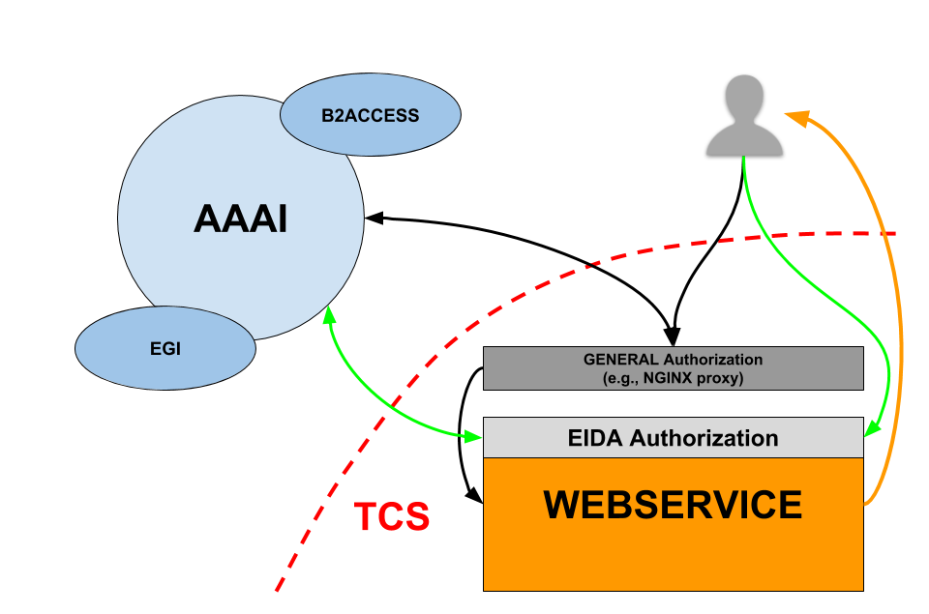
Figure 1. Simplified diagram of the authentication/authorization schema. We present two possible solutions -- the one based on B2ACCESS has been successfully tested in EIDA; the other based on EGI Check-in is an alternative solution proposed by the ICS. Both solutions are compatible with the community’s requirements. Black connectors and arrows adopt NGINX as a proxy and in green (connectors and arrows) indicate the authentication/authorization schema adopted by EIDA.

With regard to the AAAI, a dedicated seminar was organized at the Lisbon March 12-14, 2018, integration meeting, in which the Polish [CYFRONET] partners have proposed asolution for the implementation of the AAAI, based on EGI Check-in, that could be easily integrated with existing web-services. In Figure 1, there are summarised i.) the solution that adopts NGINX as a proxy (black connectors and arrows) and ii.) the EIDA solution (green connectors and arrows).
In both cases, the user places a request and the service redirects it to the AAAI service that provides authentication and sends a token back to the service for authorization to use the service itself.

After the Lisbon meeting the individual service developers have commented as follows with regard to the implementation of the AAAI.

EIDA
EIDA is starting with the activities to put into production the EIDA
Authentication System connected to the B2ACCESS instance run at Jülich
as a result of the developments and pilots run in EUDAT2020.

ESM
We are exploring the possible solutions to implement the ESM-AAAI. We have chosen to test the EUDAT-b2access technology (https://www.eudat.eu/services/b2access) for authentication and an "internal" solution for authorization. The alpha-version of ESM-AAAI is expected by the end of April.

AHEAD
Still, general ongoing internal discussion whether we should implement any type of AAAI at all.

EDSF
Still, general ongoing internal discussion whether we should implement any type of AAAI at all.

EFEHR
EFEHR web services do not consider any AAAI for the time being.

EMSC
EMSC web services do not consider any AAAI for the time being.

6. CONCLUSION
The Seismology TCS is well on the way with a number of standard services offered through RESTful web services (i.e., REST architecture based web services).
The activities carried on during the second year of the project and up to M30 evidenced:
- an effective advancement in the development of the TCS Seismology services with the prioritization of 7 services
- a good interaction between ICS and EPOS Seismology TCS
- a good interaction among different TCSs and the ICS resulting from the harmonization group (e.g., meeting held in Milano in May 2017)
With regard to the first point, it is really remarkable not only that 7 services have been prioritized and are production-ready but also that many others are also ready for being inserted in the EPOS suite once the metadata are inserted in the EPOS-DCAT-AP with the RDF extension using the tools developed by the ICS will become available. In addition, the inter-TCS harmonization group were recognized to be important to address shared concepts towards the formation of a unified framework while maximizing the use of the available resources.
With regard to the AAAI, the solution developed and implemented by EIDA on the basis of the B2ACCESS service, developed within the IT project EUDAT2020, is very valuable, although it is worth noting that 4 out of 6 main services (e.g., EIDA, ESM, AHEAD, …) are still discussing whether AAAI is needed or not. The NGINX as proxy solution described concisely above is a possible work-around that would allow the insertion of an authentication/authorization layer above the developed web-services which would help to maintain the modularity of the services while reaching the scope.
As anticipated in the previous reports, the final goal consists of providing tools that, besides helping the researchers with additional products to obtain analysis of the data reliably and quicker, include provenance procedures that will allow researchers to reconstruct all the individual steps of the workflows that have been adopted to calculate the results. In simple terms, the overall machinery adopted by EPOS ICS & TCS should provide all those ingredients/procedures/tools necessary to perform “reproducible science”.

https://github.com/epos-eu/EPOS-DCAT-AP
https://www.w3.org/TR/vocab-dcat/
https://www.w3.org/TR/turtle/
https://www.epos-ip.org/events/epos-ics-hackathon-during-epos-implementation-and-validation-workshop-lisbon-portugal-12-15
A token is like a “key” that identifies the user and its profile for authorization on predefined services.

